ERP Integration
Technical Documentation
Salesforce → MuleSoft → ERPNext Integration

Field | Details
Project Name | ERP Integration
Author | Prakashraj Kodimunja
Version | 1.0.0
Date | March 2026
Status | Live / Production
Platform | MuleSoft Anypoint Studio 4.11.0

1. Project Overview
This document describes the technical implementation of the ERP Integration project that enables real-time synchronization between Salesforce CRM and ERPNext. When a Quote is approved in Salesforce, the integration automatically creates a Sales Order in ERPNext and updates the Quote record with the result.

1.1 Business Objective
- Automate Sales Order creation in ERPNext when a Salesforce Quote is approved
- Eliminate manual data entry and reduce human error
- Provide real-time sync status feedback in Salesforce
- Ensure idempotency — no duplicate orders for the same Quote
- Handle failures gracefully with automatic retry and error reporting

1.2 Technology Stack
Component | Technology | Version
Integration Platform | MuleSoft Anypoint Studio | 4.11.0
CRM | Salesforce | API v57.0
ERP | ERPNext (Frappe) | Latest
Event Mechanism | Salesforce Platform Events | CometD
Authentication | OAuth 2.0 Client Credentials | -
Runtime | Mule Runtime | 4.11.0

2. Architecture

2.1 High-Level Flow
The integration follows an event-driven architecture:

Step | Component | Action
1 | Salesforce Quote | Quote Status changed to Approved
2 | Apex - QuoteApprovedEventPublisher | Publishes RCA_QuoteApproved__e platform event
3 | MuleSoft - Replay Channel Listener | Subscribes and receives the platform event
4 | MuleSoft - Choice Router | Checks if ERP Order already exists (Idempotency)
5a | MuleSoft - Duplicate Path | Returns existing order details, skips creation
5b | MuleSoft - Default Path | Transforms and sends order to ERPNext
6 | ERPNext | Creates Sales Order, returns Order ID
7 | MuleSoft - OAuth Request | Fetches Salesforce access token
8 | MuleSoft - Apex Callback | Calls Salesforce Apex REST to update Quote

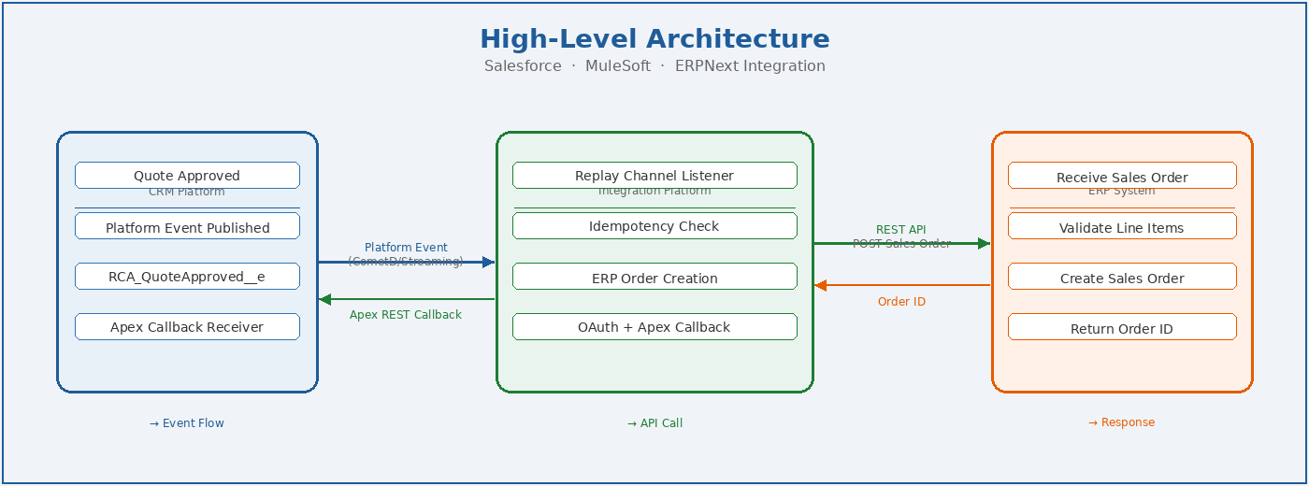

Figure 1: High-Level Architecture — Salesforce → MuleSoft → ERPNext

2.2 MuleSoft Flow Structure
The main flow is: quote-approved-event-to-erp-flow

Processor | Type | Purpose
Replay Channel Listener | Salesforce Source | Subscribes to /event/RCA_QuoteApproved__e
Set Variable | Core | Stores originalEvent from payload.data.payload
Transform Message | EE Transform | Builds ERP order payload from event data
Set Variable | Core | Stores erpRequest for callback use
Choice - Check ERP Order | Router | Idempotency check on ERP_Order_Id__c
Until Successful | Scope | Retries ERP call up to 3 times
Capture ERP Error (Try) | Scope | Captures exact ERP error response
HTTP Request (ERP) | HTTP | POST to ERPNext Sales Order API
Transform Message | EE Transform | Builds success callback payload
HTTP Request (OAuth) | HTTP | Gets Salesforce access token
HTTP Request (Apex) | HTTP | Calls Salesforce Apex REST callback

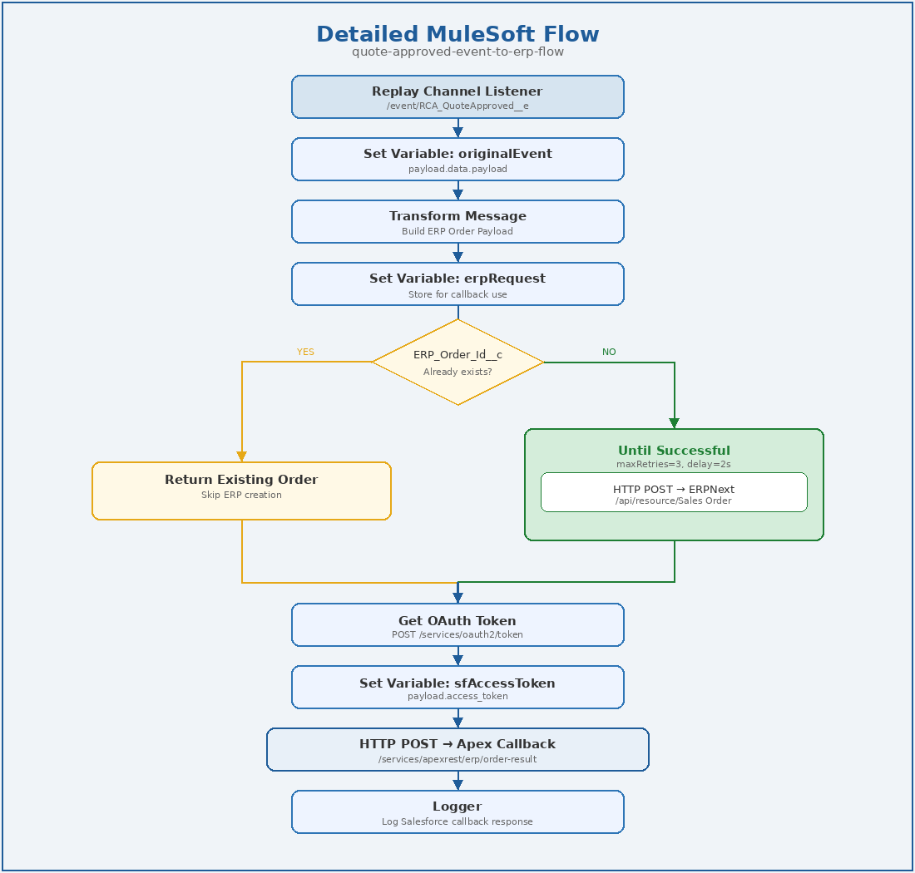
Figure 2: Detailed MuleSoft Flow — quote-approved-event-to-erp-flow

3. Salesforce Configuration

3.1 Platform Event — RCA_QuoteApproved__e
A custom Platform Event published when a Quote is approved.

Field API Name | Type | Description
CorrelationId__c | Text | Unique correlation ID for tracking
QuoteId__c | Text | Salesforce Quote record ID
QuoteNumber__c | Text | Quote number
AccountId__c | Text | Related Account ID
GrandTotal__c | Currency | Quote grand total
LinesJson__c | Long Text | JSON array of quote line items
ERP_Order_Id__c | Text | Existing ERP Order ID (for idempotency)
ERP_Order_Number__c | Text | Existing ERP Order Number

3.2 Quote Custom Fields — ERP Integration Section
Field API Name | Type | Description
Integration_Correlation_Id__c | Text | Unique ID per integration attempt
ERP_Sync_Status__c | Picklist | Sent / Success / Failed
ERP_Sync_Message__c | Long Text | Success or error message from integration
ERP_Order_Id__c | Text | ERPNext Sales Order ID
ERP_Order_Number__c | Text | ERPNext Sales Order Number
ERP_Attempt_Count__c | Number | Number of integration attempts
ERP_Last_Attempt_At__c | DateTime | Timestamp of last attempt
ERP_Last_Request__c | Long Text | Last request payload sent to ERP
ERP_Integration_Enabled__c | Checkbox | Toggle to enable/disable integration

3.3 Apex Classes

QuoteApprovedEventPublisher
Invocable method called from Salesforce Flow when Quote is approved.
- Queries Quote with all ERP fields including ERP_Order_Id__c
- Generates or reuses Integration Correlation ID
- Serializes Quote Line Items to JSON
- Publishes RCA_QuoteApproved__e platform event
- Creates Integration_Log__c record

ERP Callback Apex REST Class
REST endpoint called by MuleSoft to update Quote after order creation.
- Endpoint: /services/apexrest/erp/order-result
- Method: POST
- Updates Quote fields: ERP_Order_Id__c, ERP_Sync_Status__c, ERP_Sync_Message__c

4. MuleSoft Configuration

4.1 Global Elements
Name | Type | Configuration
Salesforce_Config | Salesforce Config | Basic connection — username, password, security token
HTTP_Request_Config_Salesforce | HTTP Request Config | HTTPS — omnicloud-6b-dev-ed.develop.my.salesforce.com:443
HTTP_Request_configERP | HTTP Request Config | HTTPS — ERPNext host
HTTP_Request_config1 | HTTP Request Config | HTTPS — omnicloud-6b-dev-ed.develop.my.salesforce.com:443

4.2 Properties File — config.properties
All credentials are stored in src/main/resources/config.properties:

sf.client.id=<Salesforce External App Consumer Key>
sf.client.secret=<Salesforce External App Consumer Secret>
sf.username=<Salesforce Username>
sf.password=<Salesforce Password>
sf.security.token=<Salesforce Security Token>
erp.api.token=token <ERPNext API Key>:<ERPNext API Secret>

4.3 OAuth 2.0 Authentication
The integration uses OAuth 2.0 Client Credentials flow to authenticate with Salesforce before making the Apex callback.

Parameter | Value
Grant Type | client_credentials
Token URL | https://omnicloud-6b-dev-ed.develop.my.salesforce.com/services/oauth2/token
Client ID | p("sf.client.id")
Client Secret | p("sf.client.secret")
Flow Type | Client Credentials (no username/password)

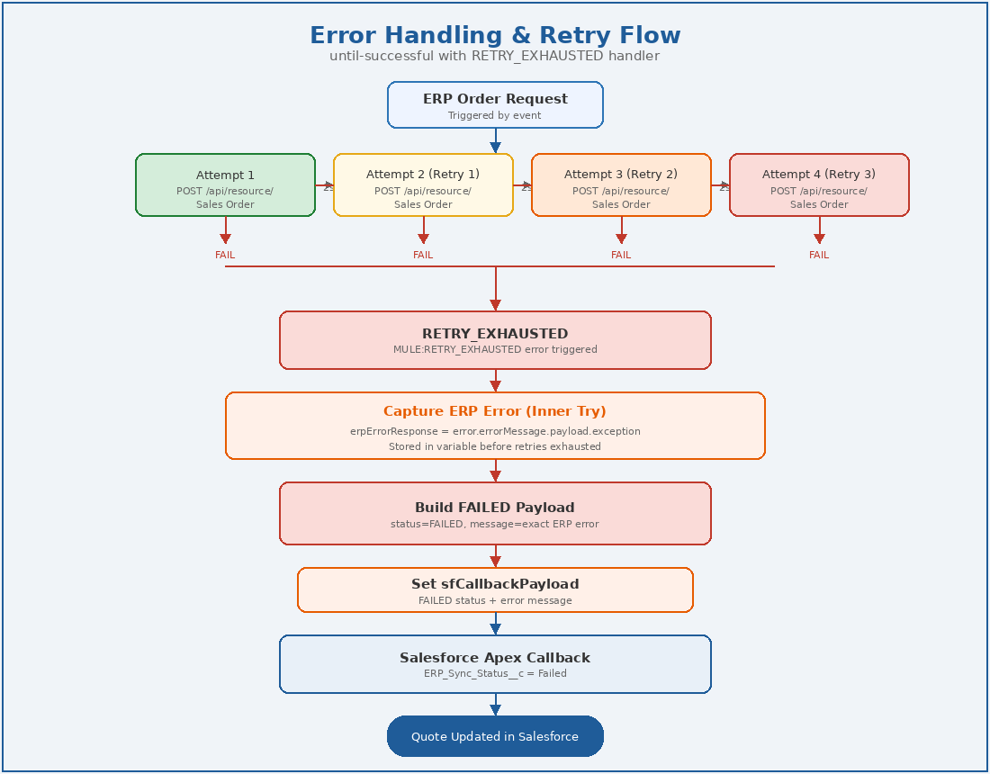
Figure 3: Error Handling and Retry Flow

5. Error Handling & Retry Logic

5.1 Retry Strategy
The ERP order creation uses MuleSoft's until-successful scope for automatic retries:

Parameter | Value | Description
maxRetries | 3 | Maximum number of retry attempts
millisBetweenRetries | 2000 | 2 second delay between retries
Total attempts | 4 | 1 original + 3 retries

5.2 Error Handlers
Handler | Error Type | Action
Inner Try (Capture ERP Error) | ANY | Captures ERP response body into erpErrorResponse variable, re-throws error
Retry Exhausted | MULE:RETRY_EXHAUSTED | Sets status=FAILED with exact ERP error message, triggers Salesforce callback
On Error Continue | ANY | Catches unexpected errors outside retry scope, sets status=FAILED

5.3 Idempotency Check
Before attempting ERP order creation, the flow checks if an order already exists:

Expression: vars.originalEvent.ERP_Order_Id__c != null
and vars.originalEvent.ERP_Order_Id__c != ""

Condition | Path | Action
ERP_Order_Id__c is populated | When (Duplicate) | Returns existing order details with 'Order already exists' message
ERP_Order_Id__c is null/empty | Default (New Order) | Proceeds with ERP order creation

6. Data Mapping

6.1 Salesforce Event to ERPNext Order
Source (Salesforce Event) | Target (ERPNext) |  | Transformation
vars.originalEvent.Customer_Name __c | customer | From Salesforce Customer JSON
now() | transaction_date | Current date formatted yyyy-MM-dd
now() | delivery_date | Current date formatted yyyy-MM-dd
LinesJson__c[].sku | items[].item_code | From line items JSON
LinesJson__c[].qty | items[].qty | From line items JSON
LinesJson__c[].netTotalPrice | items[].rate | From line items JSON

6.2 ERPNext Response to Salesforce Callback
Source (ERPNext/MuleSoft) | Target (Apex Callback) | Notes
payload.data.name | erpOrderId | ERPNext Sales Order ID
payload.data.name | erpOrderNumber | ERPNext Sales Order Number
Hardcoded: SUCCESS/FAILED | status | Based on flow path taken
Dynamic message | message | Success or error message
vars.erpRequest | requestPayload | Original request sent to ERP
payload / error | responsePayload | ERP response or error body
201 / 500 | httpStatus | HTTP status code
ERP_Attempt_Count__c | attempt | Current attempt number

7. Deployment & Configuration

7.1 Prerequisites
- Anypoint Studio 4.11.0 installed
- Mule Runtime 4.11.0
- Salesforce org with Platform Events enabled
- ERPNext instance with API access
- Salesforce External App with Client Credentials Flow enabled

7.2 Salesforce Setup Checklist
- External App created with OAuth enabled
- Client Credentials Flow enabled on External App
- Run As user configured on External App OAuth Policies
- IP Relaxation set to Relax IP Restrictions
- RCA_QuoteApproved__e Platform Event created with all required fields
- Quote custom fields created under ERP Integration section
- QuoteApprovedEventPublisher Apex class deployed
- Apex REST callback class deployed
- Salesforce Flow configured to call QuoteApprovedEventPublisher on Quote approval

7.3 MuleSoft Setup Checklist
- config.properties file created in src/main/resources
- All credentials populated in config.properties
- configuration-properties element added to erp-integration.xml
- All Global Elements configured correctly
- Application deployed and running

7.4 Running the Application
Right click project > Run As > Mule Application

Verify successful startup by checking console for:
Message source 'replay-channel-listener' successfully started
Successfully subscribed to /event/RCA_QuoteApproved__e

8. Testing

8.1 Happy Path Test
Step | Action | Expected Result
1 | Open a Quote in Salesforce | Quote record visible
2 | Change Status to Approved | Flow triggers automatically
3 | Check MuleSoft console | INFO logs showing event received and order created
4 | Check ERPNext | New Sales Order created with correct items
5 | Check Salesforce Quote | ERP Order Id populated, Status = Success

8.2 Idempotency Test
Step | Action | Expected Result
1 | Quote already has ERP Order Id | ERP_Order_Id__c is populated
2 | Re-approve the Quote | Event published again
3 | Check MuleSoft console | Logs show 'ERP order already exists'
4 | Check ERPNext | No new duplicate order created
5 | Check Salesforce Quote | Status = Success, message = Order already exists

8.3 Retry/Failure Test
Step | Action | Expected Result
1 | Set wrong ERP API token in config.properties | ERP will reject requests
2 | Approve a Quote | Event triggers integration
3 | Check MuleSoft console | 4 attempts logged with 2s gaps between each
4 | After 3 retries | RETRY_EXHAUSTED error triggered
5 | Check Salesforce Quote | Status = Failed, exact ERP error in Sync Message

9. Integration Log Object
The Integration_Log__c custom object in Salesforce serves as the single source of truth for every integration request and response. It provides complete visibility into what was sent, what was received, and the outcome of each attempt — making it the primary tool for debugging and auditing.

9.1 Object Fields
Field API Name | Type | Description
CorrelationId__c | Text | Unique ID linking the log to a specific integration
Status__c | Picklist | Current status: Sent / Success / Failed
Direction__c | Text | Direction of integration: Salesforce to MuleSoft
Target_System__c | Text | Target system name: MuleSoft
Request__c | Long Text | Full JSON request payload sent to ERPNext (line items)
Error_Message__c | Long Text | Error message if integration failed
Attempt__c | Number | Attempt number for this integration event
Related_Quote__c | Lookup (Quote) | Reference to the related Salesforce Quote record

9.2 When a Log Record is Created
A new Integration_Log__c record is created every time the QuoteApprovedEventPublisher Apex class is invoked — i.e., every time a Quote is approved and the platform event is published.
Scenario | Status | What is Logged
Event published successfully | Sent | Correlation ID, line items JSON, attempt count
Event publish failed | Failed | Correlation ID, error message from EventBus

9.3 How to Use for Debugging
The Integration Log is the first place to check when investigating any integration issue:
Debugging Scenario | What to Check in Log
Order not created in ERPNext | Check Status__c — if Sent, MuleSoft received it; if Failed, event publish failed in Apex
Wrong items sent to ERP | Check Request__c field — shows exact JSON payload sent to ERPNext
Multiple orders for same Quote | Check Attempt__c count and multiple log records for same Related_Quote__c
Error from ERPNext | Check Error_Message__c — shows exact exception returned from ERP
Missing log record | Apex class may not have been triggered — check Salesforce Flow configuration

9.4 Log Record Lifecycle
- Created when Quote is approved and event is published
- Status starts as Sent — confirms MuleSoft has received the event
- Quote fields are updated by MuleSoft callback — the log record itself is not updated after creation
- Each re-approval creates a NEW log record with incremented attempt count
- All historical log records are preserved — complete audit trail available at all times

9.5 Querying Logs via SOQL
To find all logs for a specific Quote:
SELECT Id, CorrelationId__c, Status__c, Attempt__c, Request__c, Error_Message__c, CreatedDate
FROM Integration_Log__c WHERE Related_Quote__c = '0Q0xx...' ORDER BY CreatedDate DESC
To find all failed integration attempts:
SELECT Id, CorrelationId__c, Error_Message__c, Related_Quote__c, CreatedDate
FROM Integration_Log__c WHERE Status__c = 'Failed' ORDER BY CreatedDate DESC

10. Troubleshooting
Error | Cause | Fix
HTTP 400 Bad Request on token endpoint | Wrong domain URL or credentials | Use org My Domain URL, check credentials
'request not supported on this domain' | Using login.salesforce.com instead of My Domain | Change token URL to omnicloud-6b-dev-ed.develop.my.salesforce.com
'until-successful' retries exhausted | ERP rejecting requests after all retries | Check ERP API token, item codes, customer name
Status stuck at Sent | RETRY_EXHAUSTED handler not matching | Ensure error type is MULE:RETRY_EXHAUSTED
Duplicate orders created | ERP_Order_Id__c not in event payload | Add field to SOQL query and event payload in Apex
LinkValidationError from ERPNext | Item Code not found in ERPNext | Verify item codes exist in ERPNext
Test Connection failed in Studio | Properties not resolved at design time | Ignore — only fails in GUI, works at runtime

11. Change Log
Version | Date | Author | Change
1.0.0 | Mar 6, 2026 | Prakashraj | Initial implementation — event subscription and ERP order creation
1.1.0 | Mar 10, 2026 | Prakashraj | OAuth 2.0 authentication via Client Credentials flow
1.2.0 | Mar 10, 2026 | Prakashraj | Fixed External App domain URL for token endpoint
1.3.0 | Mar 13, 2026 | Prakashraj | Added idempotency check using ERP_Order_Id__c
1.4.0 | Mar 13, 2026 | Prakashraj | Added retry system — 3 retries with 2s delay
1.5.0 | Mar 13, 2026 | Prakashraj | Moved credentials to config.properties
1.6.0 | Mar 16, 2026 | Prakashraj | Enhanced error messages with exact ERP exception details

End of Document

